The project plan is to establish and maintain a plan that defines project activities. Compared with the previous project development process, it can better control the project execution progress. According to the time node, accurately graSG the project development progress and development time, and can achieve project development responsibility To people.

The following sections plan and arrange the project by establishing estimates, specifying project plans, and planning commitments.

**SG 1 Establish estimates**

Software project estimation is based on accurate survey data and project available resource information.It predicts the size, workload, progress, and cost of the estimated object and defects.It is the basis for project planning.

**SG 1.1 Estimated project scope**

The scope of project estimates includes software scale, workload, and work progress.

1. Estimate product size

The estimated product size includes the number of code lines and function points. In the image recognition system of a distributed system, it represents the number of code lines estimated during the system implementation process and the expected function points of the product.

1. Estimated workload

Estimate how long it will take to complete the project based on the number of people working in the group and the efficiency of each person's daily work.

1. Estimate progress

Estimate the work progress of the entire project according to the workload and number of workers.

1. Cost Estimate

The cost estimates here include human and software and hardware costs, learning, training, risk, and maintenance costs. Here, in particular, the hardware costs of leasing multiple servers, as well as labor costs, because this accounts for the vast majority.

1. Defect number estimation

Estimation of the number of defects, an estimate of the workload and schedule affected by the number of defects. This refers to the potential defect risk within the project.

1. Estimate improvement

Estimates are provided within a certain range, and the range is regularly improved as the project progresses to provide greater accuracy.

Here you can determine the project scope and boundaries according to user needs, form WEBs based on lifecycle products, analyze reusable, purchased, outsourced components, analyze various support activities, such as qa, cm, etc., project goals smart (clear, measurable, (Acceptable, achievable, time-bound). Visualization can be performed by technology WEBs (product breakdown structure), sow, and project WEBs (project work breakdown structure).

**SG 1.2 Establish estimates of work product and task attributes**

Establishing the estimation process of work product and task attributes will be divided into three aspects to practice, determine the product technical route, analyze product characteristics, determine the estimation method, and estimate based on WEBs.

After the estimation, the following estimation results will be produced.The results include function points, lines of code, business, functional item interfaces, etc.In this process, it is necessary to record the difficulty, complexity, assumptions and processes of analysis.

**SG 1.3 defines the project life cycle**

It is very important to choose the "v model" for the project declaration cycle, and to clarify the project life cycle and phases. The "incremental development model" is used to define the project life cycle and achieve the phase delivery model. The project can be continuously displayed or delivered to the customer within the determined phase. In terms of demand flexibility, this model is at an intermediate level.

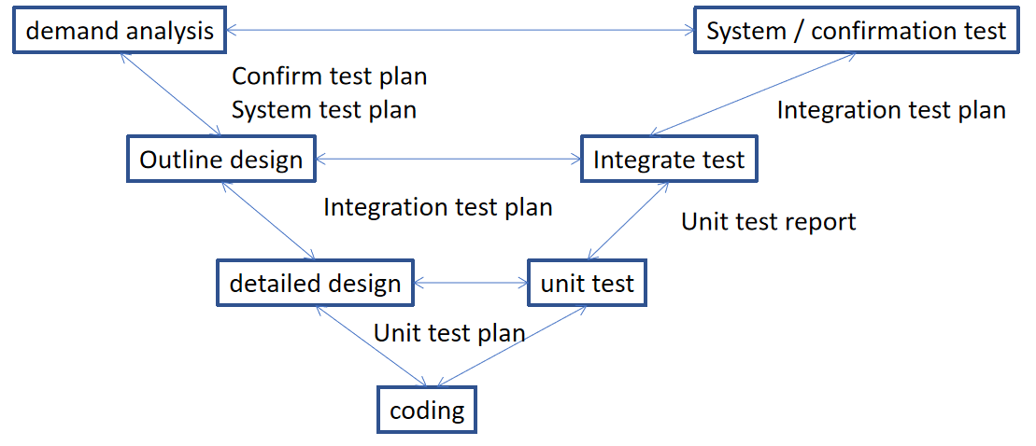

**SG 1.4 determine workload and cost estimates**

Collect methods or historical data used for estimation, use estimation methods or historical data to estimate project workload and costs. In the estimation, consider the basic resource requirements of management, development, testing, production, etc. Analyze risks, human resources, tools, methods, Environmental impacts can be analyzed through cost and budget tables.

**SG 2 make a project plan**

**SG 2.1 establish budget and schedule**

The budget and schedule are established here to reflect the project progress and budget implementation:

|  |  |  |  |  |  |
| --- | --- | --- | --- | --- | --- |
| project name | Modeling and Implementation of Image Recognition Based on Distributed Computing | | | | |
| Project start time | 2019.12.09 | | Project completion time | 2019.12 | |
| Project budget schedule settlement progress and review | | | | | |
| Financial signature |  | Project manager signature |  | Review and sign |  |
| Receiving time |  | Submission time |  | Review time |  |
| Project settlement statement settlement progress and review | | | | | |
| Estimated cost |  | Actual cost |  | Review and sign |  |
| Receiving time |  | Submission time |  | Review time |  |

**SG 2.2 Identify project risks**

Identifying risks is the process of judging which risks might affect the project and recording its characteristics. The main role of this process is to document existing risks and accumulate knowledge and skills for project teams to predict future events.

The input can be:

1. Risk management plan
2. Cost management plan
3. Schedule management plan
4. Quality management plan
5. Human resources management plan
6. Scope benchmark
7. Activity duration estimate
8. Stakeholder Register
9. project files
10. Purchase documents
11. Career environmental factors
12. Organizational process assets

The work employed can be:

1. Document review
2. Information collection technology
3. Checklist analysis
4. What-If Analysis
5. Graphic Technology
6. swot analysis
7. Expert judgment

The output can be a risk register.

**SG 2.3 data management plan**

Part of a business plan is arranging how to use data in project development. This is why companies need a good and stable data management plan. This plan helps everyone to know exactly what they need and what to do if they need it. The following steps are available:

(1) Define everyone's role

There may be many people involved in a company's project. However, even if there are only two or three people, the role of each person needs to be clearly defined. In this way, when you need to do something, you can refer to the plan and give suitable candidates. In the long run, this will save a lot of time because companies often cannot find the right people through hiring in the short term.

(2) Avoid passive voice

The passive voice is ambiguous because it does not define the subject. This makes the planning document difficult to read because the reader cannot be sure what is said. For example, "you need to pay before the plan is signed", "do not tell us", etc. These words. Instead, it should be "the developer will pay the fee because the park and recreation department will sign the plan.

(3) outline the data being collected

Businesses need to think clearly about what is being collected and why it is being collected. List each type of data that needs to be in the data plan and the reasons for doing so. If the question needs to be answered, this makes it possible for everyone to answer.

(4) Delete unnecessary words

When writing a document, pay attention to the number of words used. Generally, planning documents do not need words and phrases that are not meaningful to the text. If you cannot express your opinion, you need to streamline.

(5) How to collect data plan

Businesses need a plan to explain how they are looking to collect data. There may be several different approaches, so make sure they are all included. When collecting data, at least one person needs to be assigned the task of viewing this data.

(6) Decide how to protect the collected data

Once a business has data, it needs to be protected according to the laws of the region in which it is located. This is an important step, so make sure you don't ignore it. The business also needs to outline how to ensure that no plagiarism will occur and quote all of its source.

(7) Split text with subtitle

When writing a plan, you can split the text with subheadings. This clearly highlights each part of the plan and makes it easier to read. In addition, it will be easier to backtrack and find the information you need if you need it later.

(8) plan how to store data

People know how data is stored. The stored data needs to be secure and accessible only by authorized personnel. In addition, businesses need a backup plan in case of a hard drive failure or other disaster. A good way to do this is Keep your data storage in at least two different physical locations so that if one is damaged, there is still a backup.

(9) Points of use

They are often easier to read if they are used in a plan. They are especially useful when detailing the steps required to execute the plan. It will be easier when you want to review the plan later, so it is usually a the best choice.

**SG 2.4 required knowledge and skills plan**

Technical skills refer to the ability to understand and be proficient in a specific activity, especially activities that include methods, processes, procedures, or techniques. A good project manager should have the relevant technical experience or knowledge required for the project. Technical skills are included in specific Expertise and analytical skills to apply management tools and techniques in situations such as:

(1) Special knowledge of using project management tools and techniques

Implementing project management in the field of economic construction, especially in the construction of construction projects, is of great significance for improving the quality of the project, shortening the construction period, and saving costs. Goals and functions.

(2) Related expertise

Only after mastering certain professional knowledge in these aspects, in the process of project implementation, can you be handy when encountering events related to related majors, and be invincible when dealing with economic problems.

(3) Project technology and methods

Knowledge of cloud computing, distributed systems, and machine learning is required in this project.

(4) Related project knowledge

The project manager should also understand the relevant project knowledge and understand the methods, processes and procedures of the project.Only with these comprehensive knowledge can various management techniques be flexibly applied in the project management process.

(5) Rich practical experience

The project manager has to deal with various problems that occur in the project operation at any time, so he should have rich project practical experience in order to quickly make decisions on various problems that arise at the construction site.

**SG 2.5 plan stakeholder engagement**

In this project, the project participants include the project developer and the requester. Here, it can be called Party A and Party B.